**Project Development Phase**

**Team Id**: PNT2022TMID12449

**Project Name**: Analytics for Hospitals' Health-Care Data

**Project Development Phase**

**Sprint 3**

DASHBOARD SHOWING PIE, STACKED BAR, WATERFALL AND PIE CHARTS

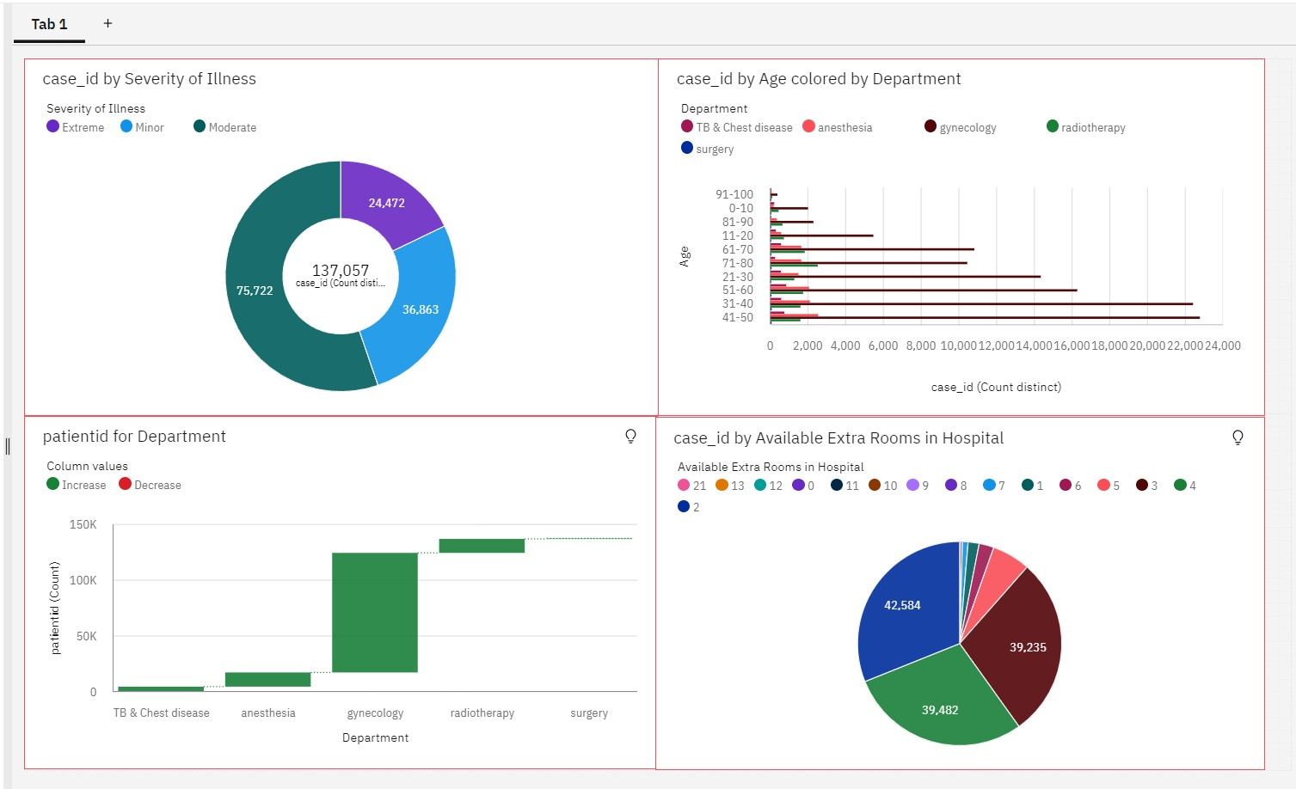

**Dashboard with Hierarchy Bubble and Radial Visuals:**

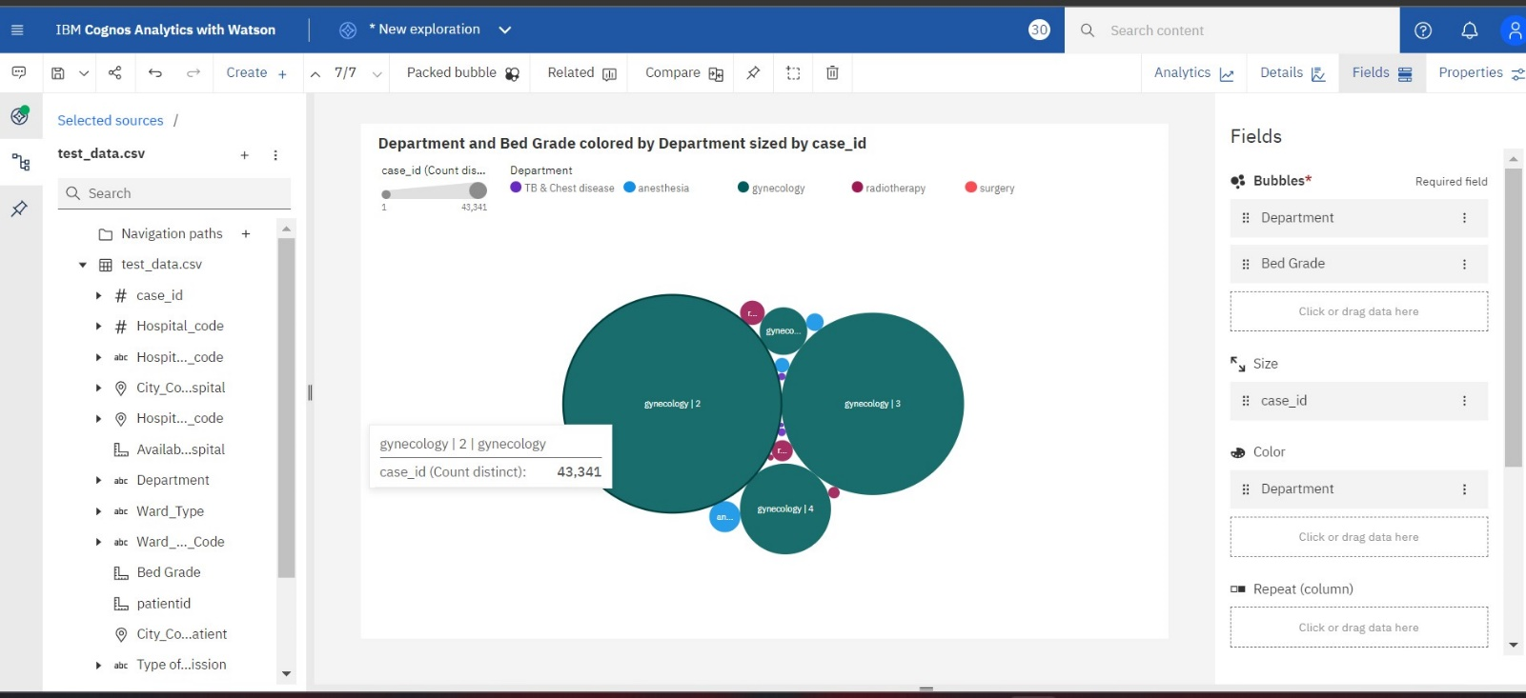

**DASHBOARD OF NO.OF PATIENTS**

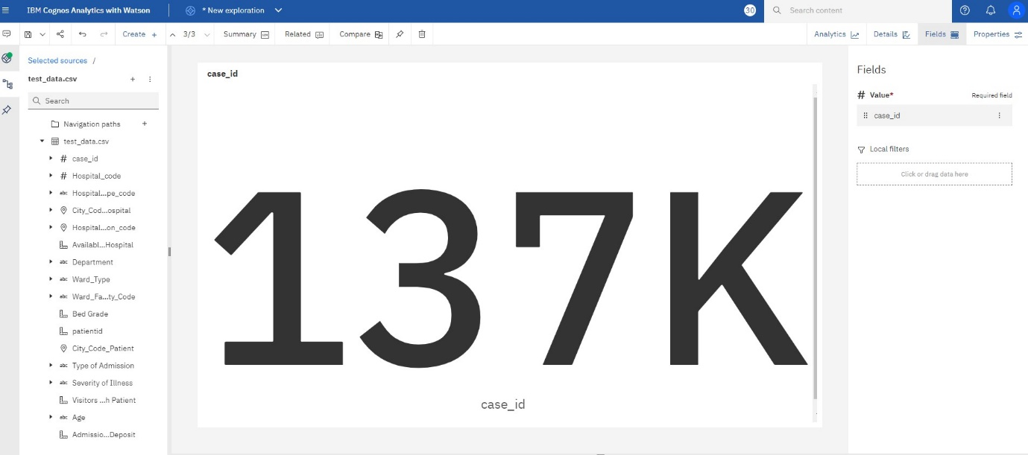

**AGE WISE PATEINTS WITH DEPARTMENT AND SEVERITY FILTERS**

